Rodrigo Brasil 10/2023

### **Part 1: Server Shopping**

<https://www.newegg.com/p/2BA-018S-00003?Item=9SIA8H5JY61452>

I chose this server because it's a great price per performance and components server to start with and build up for what it's needed!

For the specs it has:

**Name**: Gigabyte Server G292-Z44 2U HPC Server SP3

**CPU**: AMD EPYC 7003, supports up to two

**Motherboard**: MZ42-G20

8 x FHFL PCIe Gen4 x16 slots for GPUs

2 x LP PCIe Gen4 x16 slots for add-on cards

2 x 10Gb/s BASE-T LAN ports (Intel® X550-AT2 controller)

1 x Dedicated management port

**RAM**: 128GB’s x 16 x DIMM slots DDR4 memory supported only

**Storage**:

1TB SSD x 4 2.5" Gen3 NVMe/SATA hot-swappable bays

1TB SSD x 4 2.5" SATA hot-swappable bays

**Power** **supply**: 2+0 2200W 80 PLUS Platinum power supplies

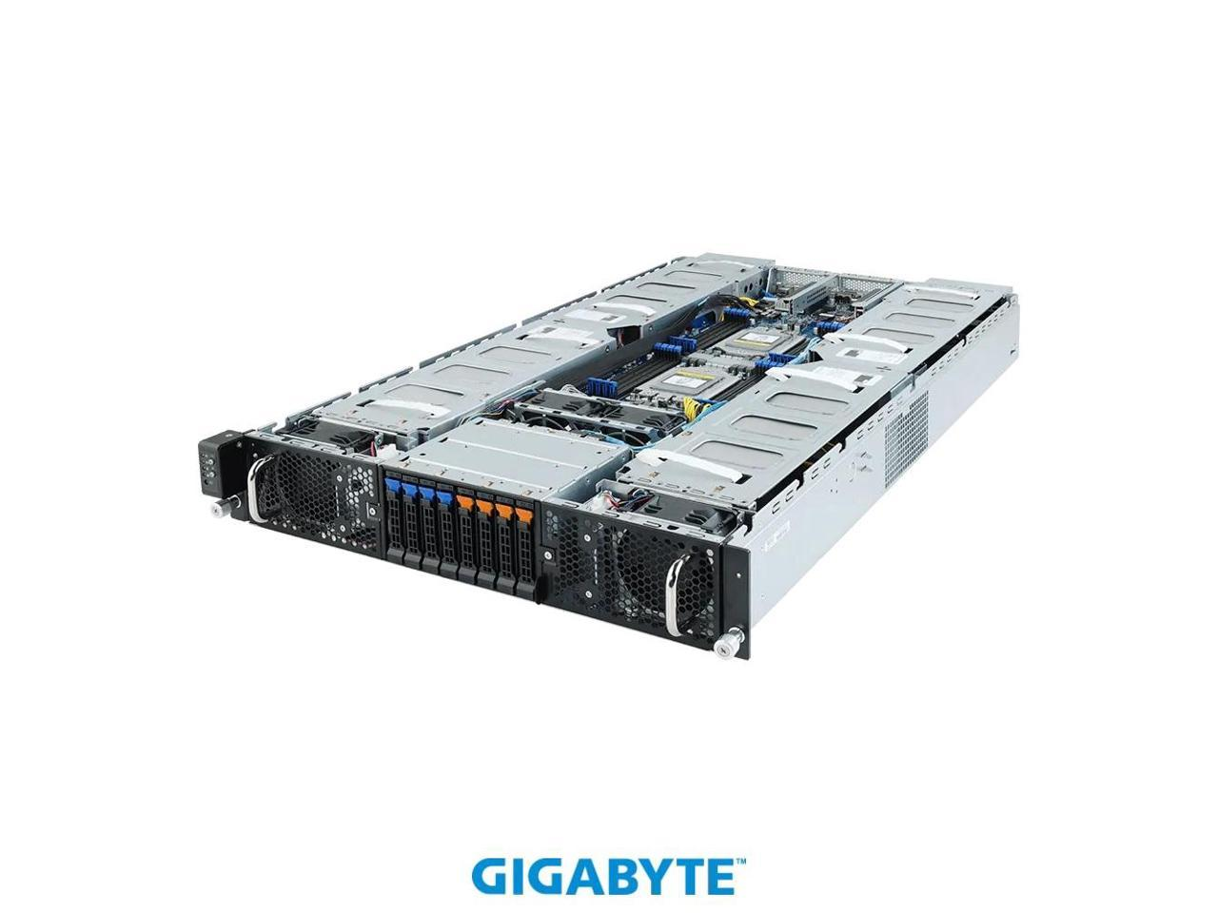

### **Part 2: Server Deployment**

Windows Server 2019 VM Installation with the specifications: 2 core CPU, 4 GBs of RAM and 50 GBs of hard drive storage.

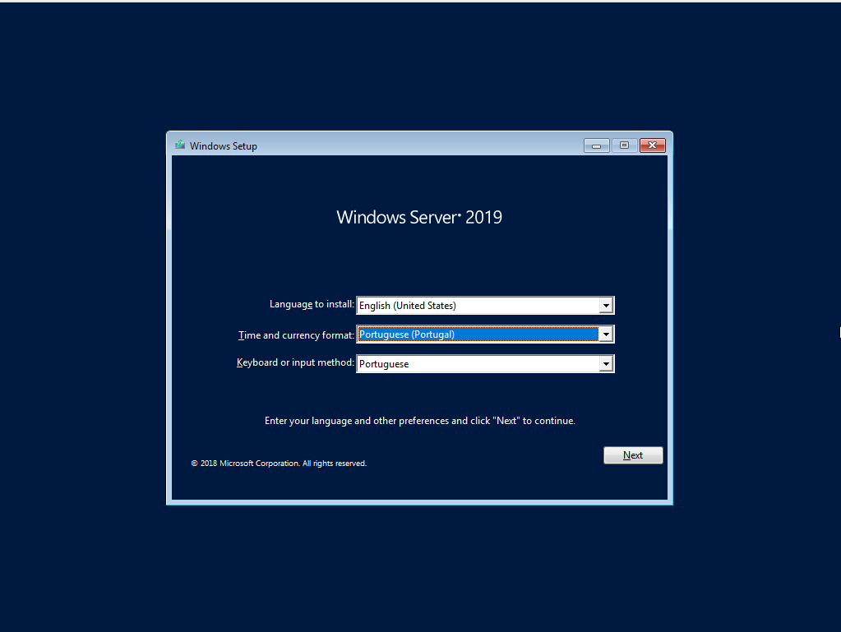

Language, time zone and keyboard installation

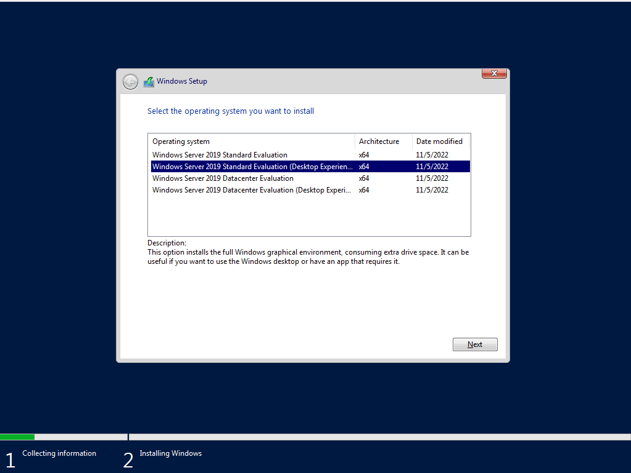

Windows server 2019 version selection

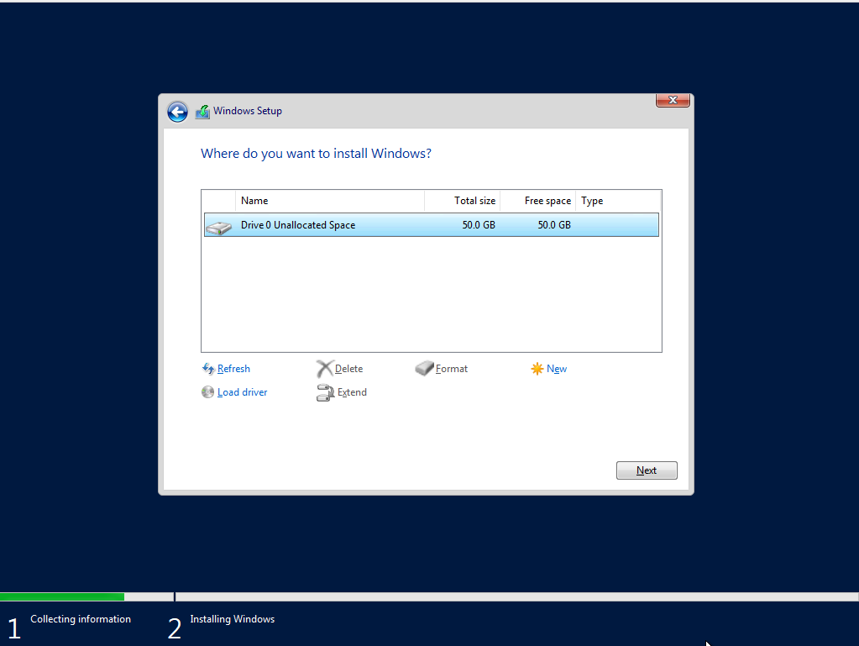

Partition selection

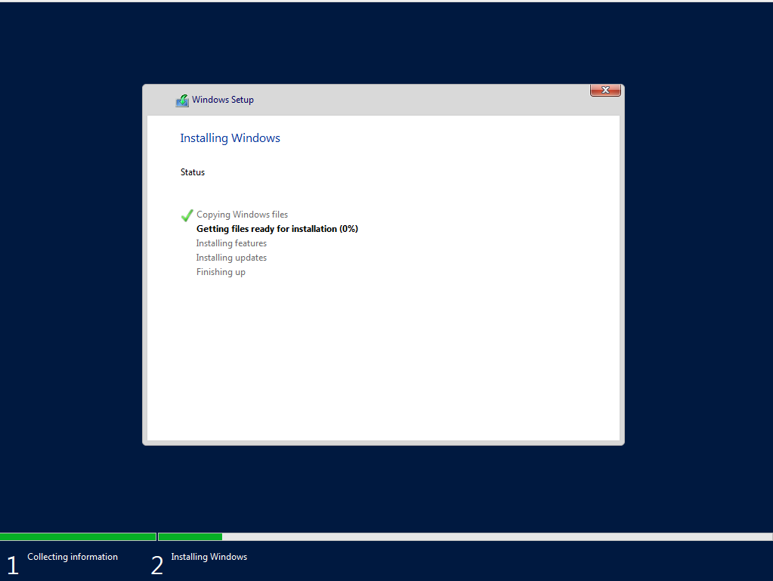

Installation

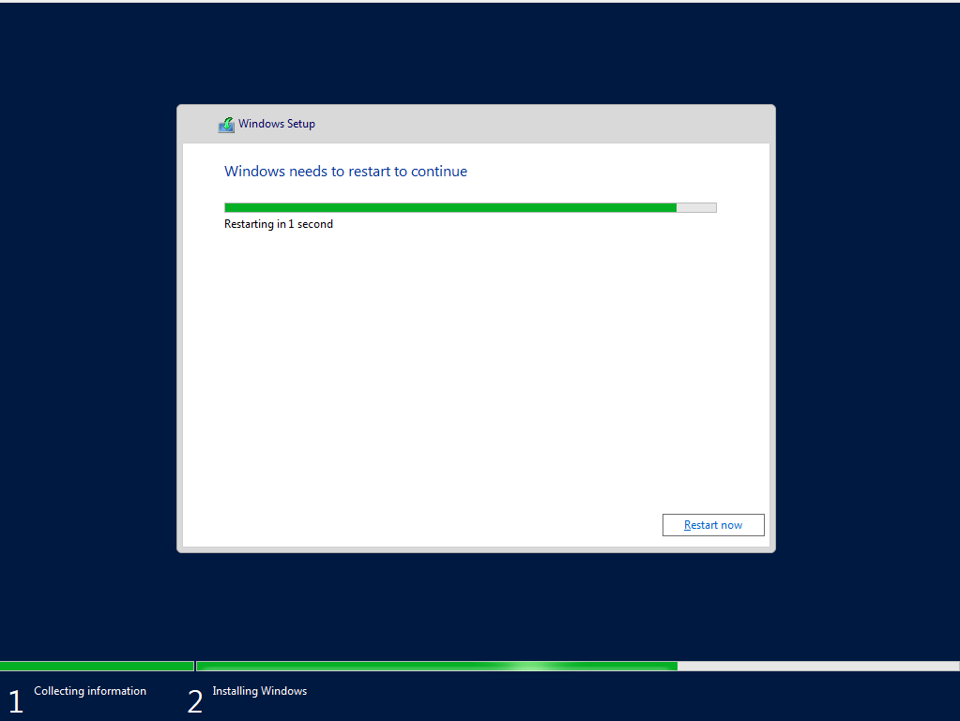

reboot after installation

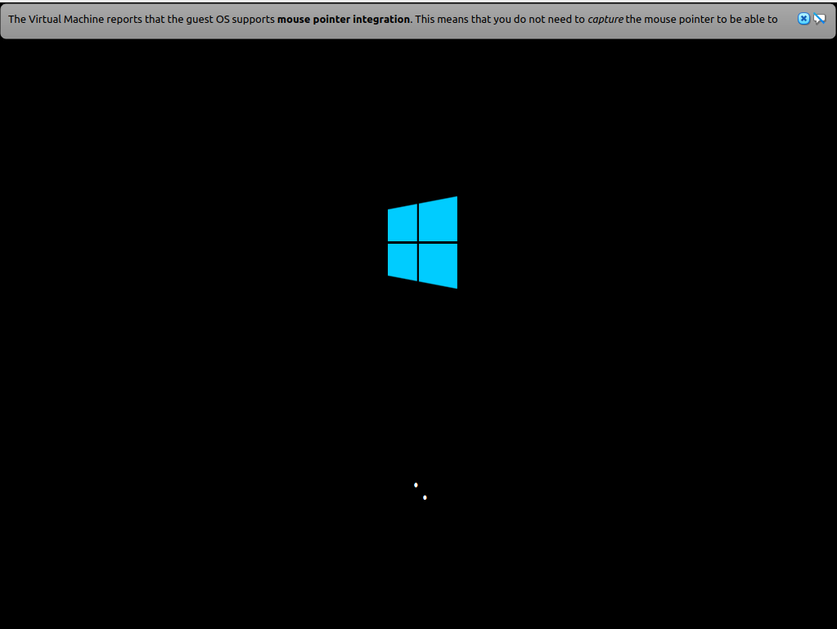

successful boot after installation

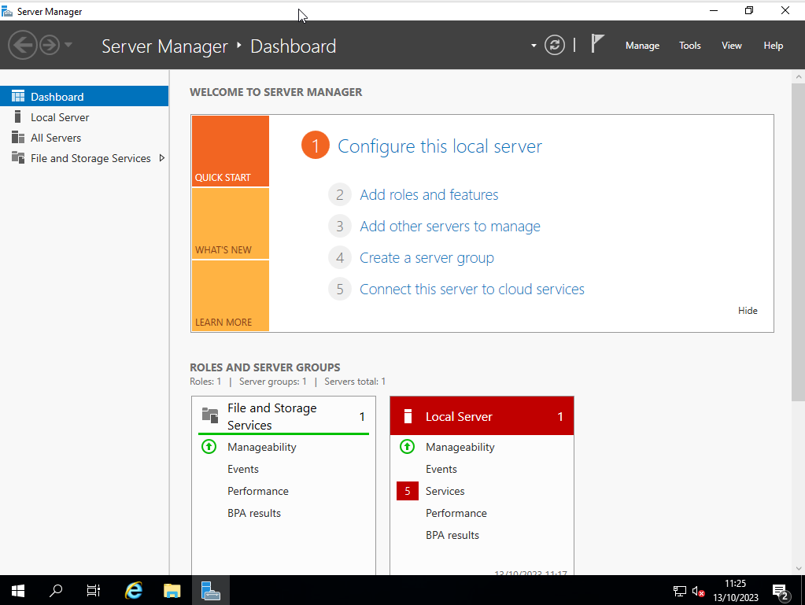

we are in

Installation of VirtualBox Guest Additions on the Windows Server 2019 VM

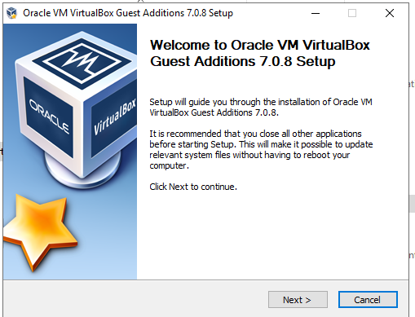

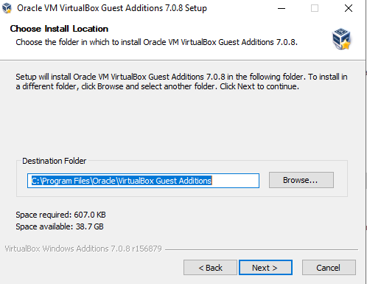

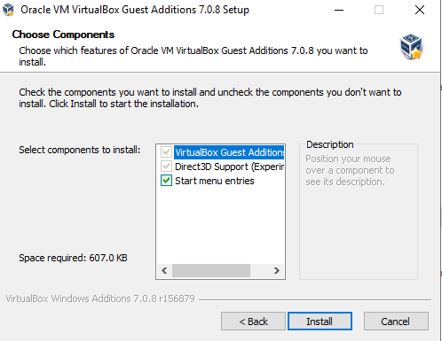

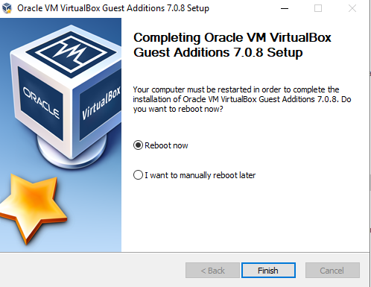

### **Part 3: Network Connectivity**

pfSense VM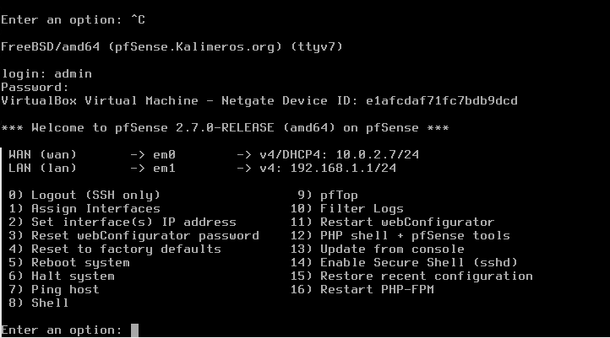

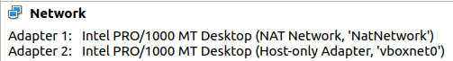

Windows Server 2019 VM network NIC’s (only vboxnet0 has the cable connected)

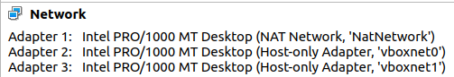

pfSense VM network NIC’s (only the NAT Network and vboxnet0 are connected)

Static IP assigned using DHCP reservation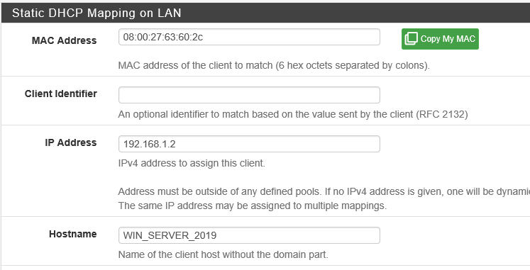

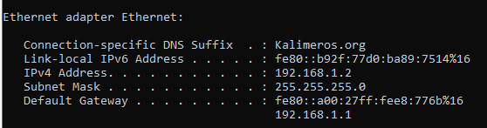

New IP given to the Windows Server 2019 VM

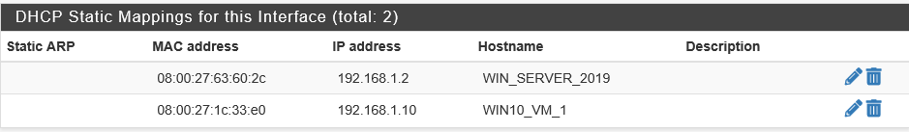

DHCP Static IP’s for Win Server and Win10 VM’s

I chose these IP’s because it made more sense to me and are organized.

From 192.168.1.2 to 192.168.1.9 are reserved for maybe a VPN or another firewall for exemple and from 192.168.1.10 onward are reserved for other machines!

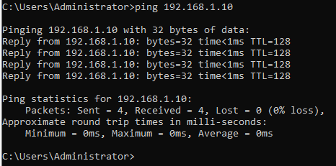

Confirmed connection from Win Server to Win10 VM

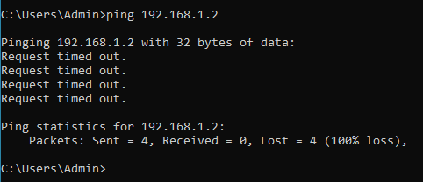

But failed to ping Win Server from the Win10 VM.

I’m assuming it's because of the firewall rules on Win Server VM.

They probably are connected but aren’t able to receive ICMP echo requests

### 

### **Part 4: Updates**

Pending Updates for the Win Server VM

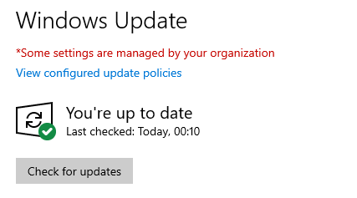

Win Server 2019 VM is up to date!

### **Part 5: Topology**

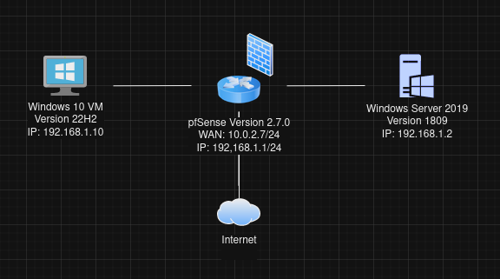

Final Topology